## Assignment #3

## Fall 2020

Create a page relating to voting eligibilty.  Have an H1 heading that says "Why It’s So Important". Write one or two short pdaragraphs about why voting is important. Don’t overthink this part -- obviously voting is important, but that’s not the main point of this particular assignment. Place these paragraphs in a div section called 'about_voting.

**Change the size of the image:** Display [this image](http://condor.depaul.edu/ymendels/238/vote_by_mail.jpg) of a voting pin. Have 3 buttons underneath. One should say 'Shink the Image to Half’ and should make the image 356x544 (height x width). Another should say 'Shrink the Image to 1/3’ and make it 237x363. A third should say 'Restore Pic' and make it its original size of 712x1088. The code to do each of these should be inside the value of the 'onclick' attribute of the button.

**Change the border:** Create a class that creates a blue, dotted, 6 pixel border.  When the user hovers over the picture of the voting pin, the class should be applied. When the user moves the mouse off of the image, the class should be removed.  There are a few ways to do this, but as a hint, let me suggest one possibility: that you use the 'onmouseover' and 'onmouseout' attributes inside the <img> tag that you use to display the image.

**Change the font:** Have a select box with 3 fonts in it:  Helvetica, Arial Narrow, Times New Roman. The first option in the box  should be 'Select a Font'. Each time the user selects a font, invoke a function that changes the text of the ‘about_voting’ div to that

font. Note: You must invoke this function from inside the <select> tag. Look up and use the ‘onchange’ attribute to do this.

**Am I Old Enough to Vote**?  Have a text field that asks the user to enter the year they were born. In order to vote, someone must be at least 18 years old. So the current year (2020) minus their birth year must be at least 18. (We will ignore the birth month to keep things simple). Then have a button that invokes a function that says whether they can vote or not. So if the user enters 2001, you will say: "Because you will be 19 years old in 2020, you are eligible to vote."  You should output this using the 'append()' function as a new paragraph at the end of the 'about_voting’ div section.

Here is how your page might look. Note that I typed 2005 as my birth year, so at the end of the first paragraph, the page tells me that I am not old enough to vote.

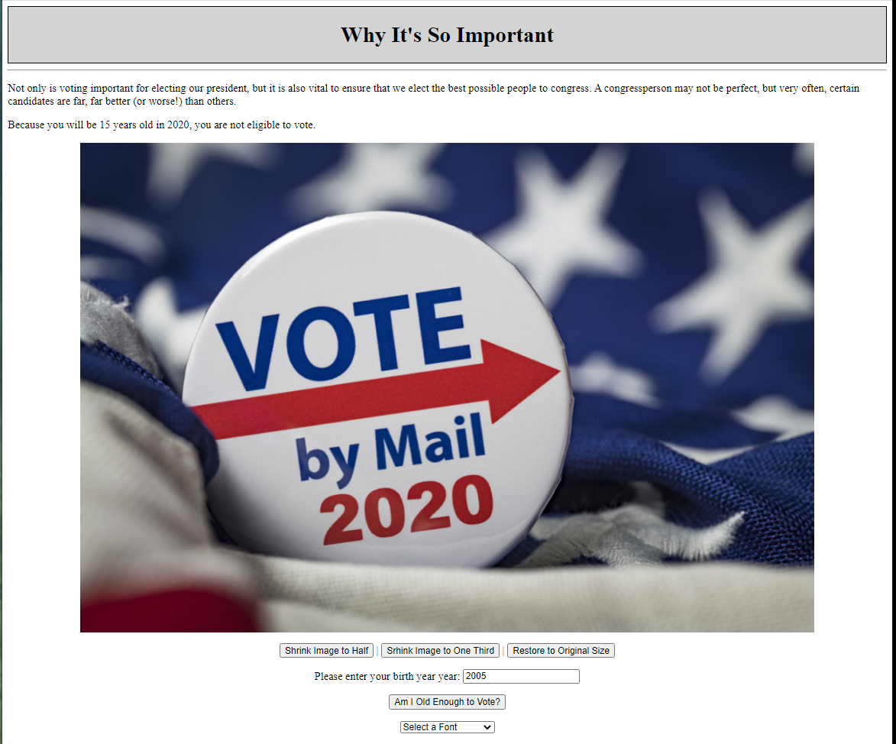

## Assignment Submission:

Same requirements as last time (and as in the future):

1.      **As always, be sure to use the assignment checklist** which can be found at the top of the *class web page* (not D2L).

2.      Please zip (i.e. do not use 7ZIP, RAR, etc) all of your files together and name the file using the following format:  **lastname_firstname_238_assignment1.zip**

3.      Note: Throughout the course, any accessory files that are used in your assignment such as images, external CSS files, external JS files, etc should be included in your zip file.